Task on CloudTrail & CloudWatch
1.Enable CloudTrail monitoring and store the events in S3 and CloudWatch log events.
Steps:
Go to S3 ,Click Create bucketBucket name: my-cloudtrail-logs-unique-name
Keep default settingsCreate bucket
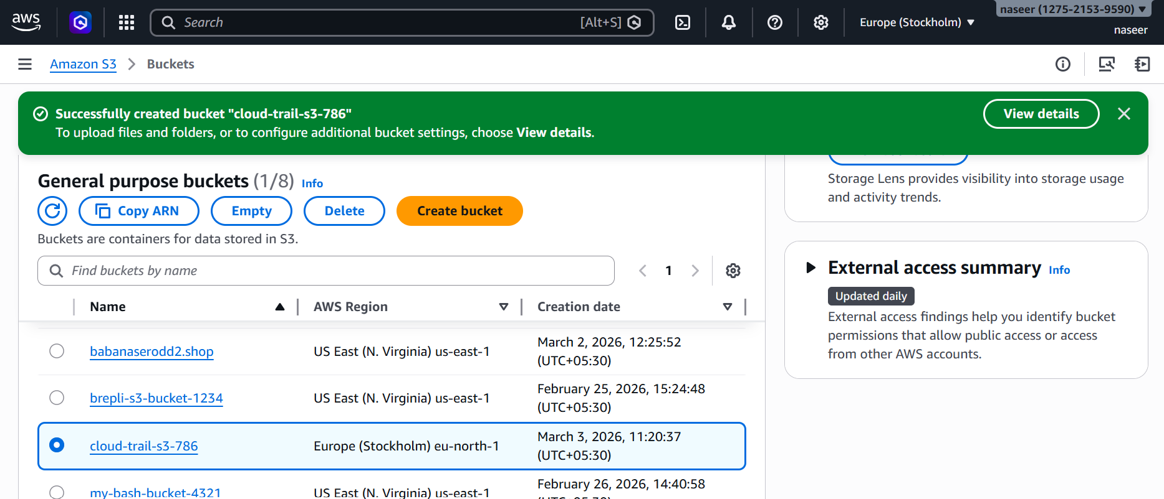
Create CloudWatch Log Group
Go to CloudWatchLogs → Logs ManagementCreate log group
Name: Cloud-Trail-786

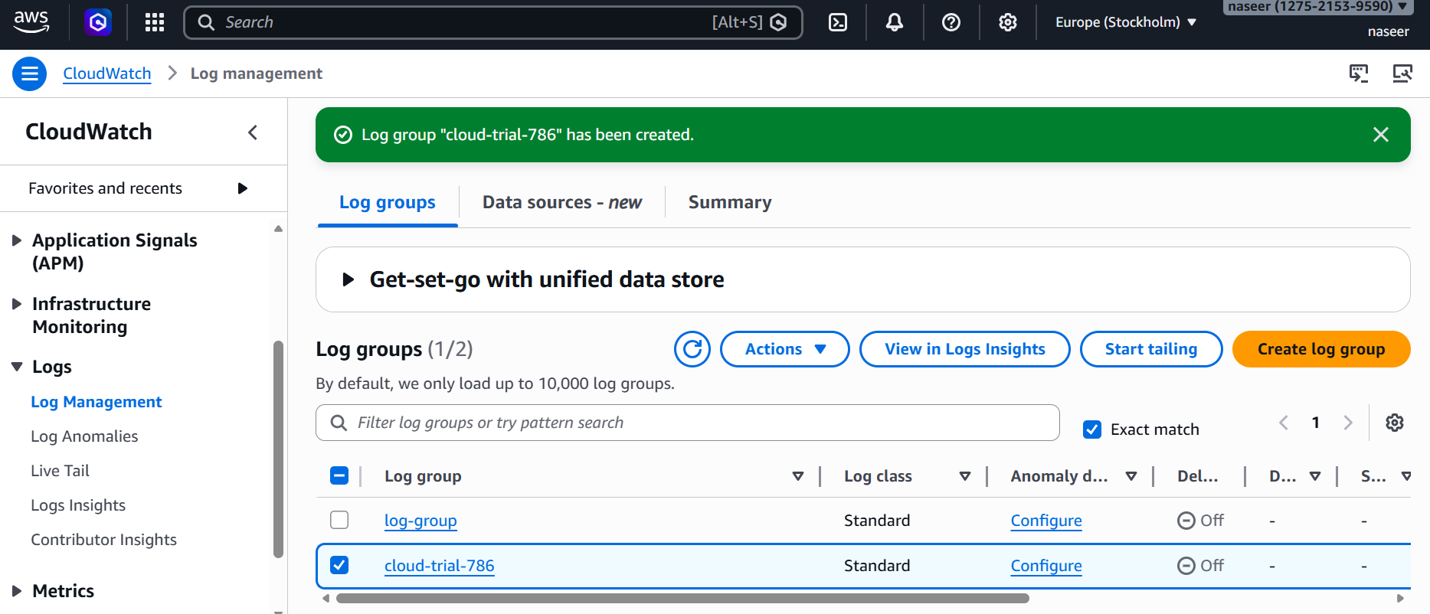
Go to IAM → Roles → Create RoleAWS serviceUse case: CloudTrail
Attach policy: CloudWatchLogsFullAccess
Role name: CloudTrail-CloudWatch-RoleCreate role
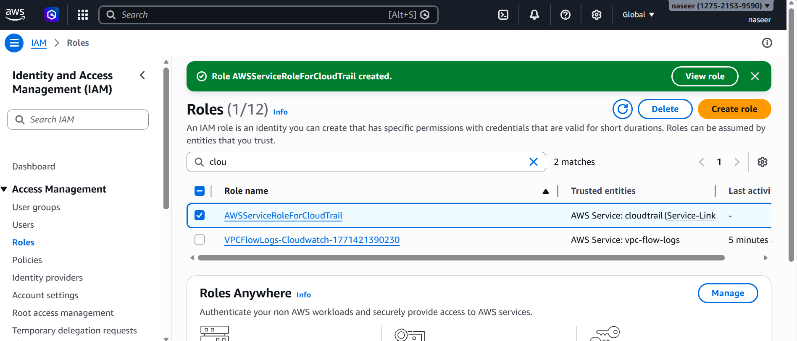
Go to CloudTrail and Click Create trail
Trail name: cloud-trial-role-786
Storage location:
  - Choose existing S3 bucket
  - Select your bucket
Enable CloudWatch Logs
  - Select log group: CloudTrail-Logs
  - Select role: CloudTrail-CloudWatch-Role
Choose: Management events → Read/Write
Create trail
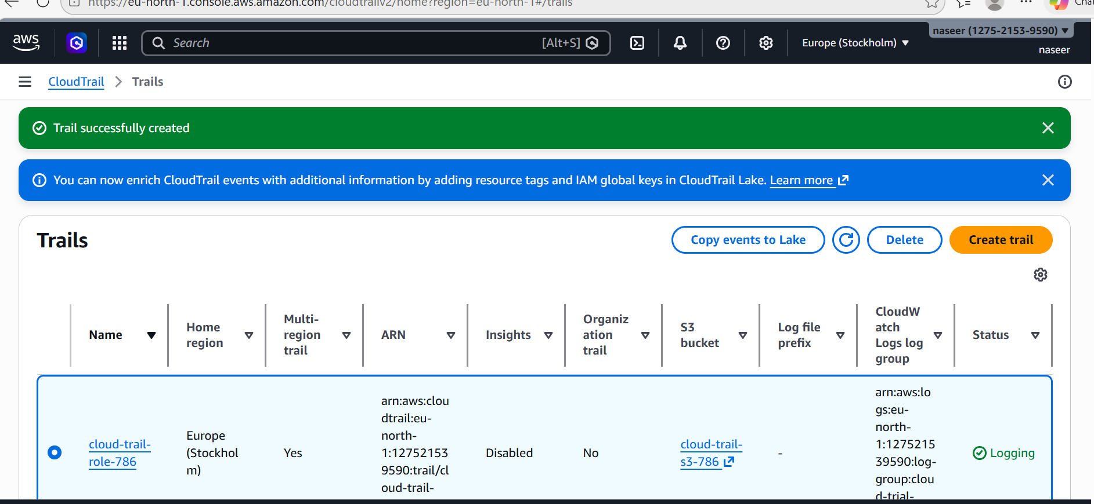
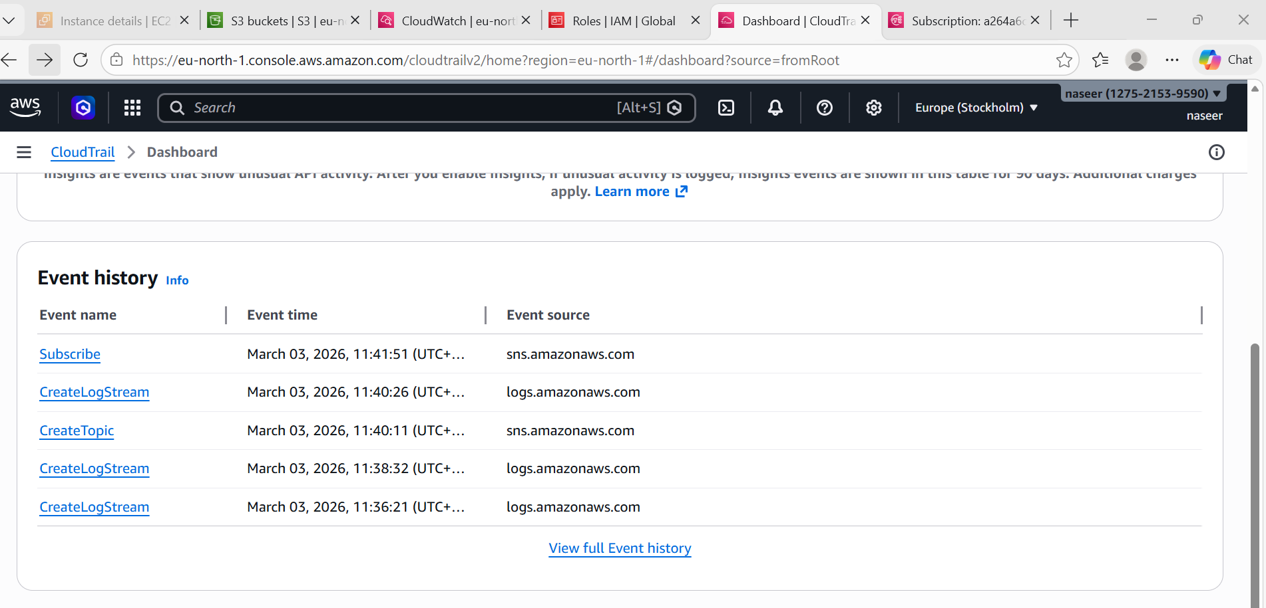
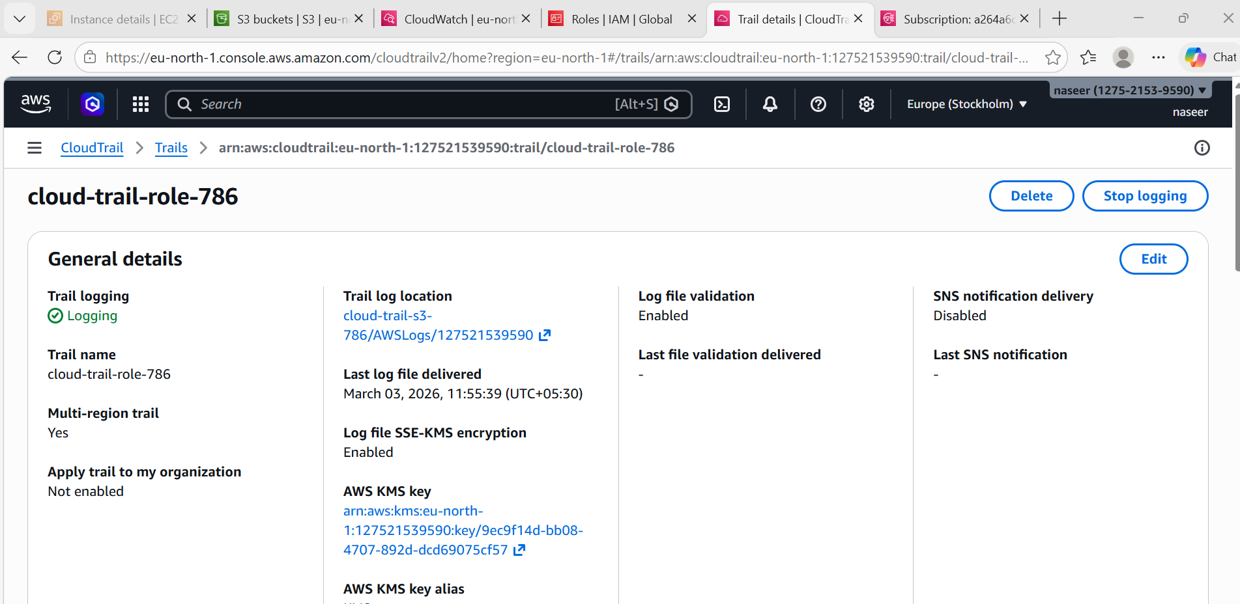
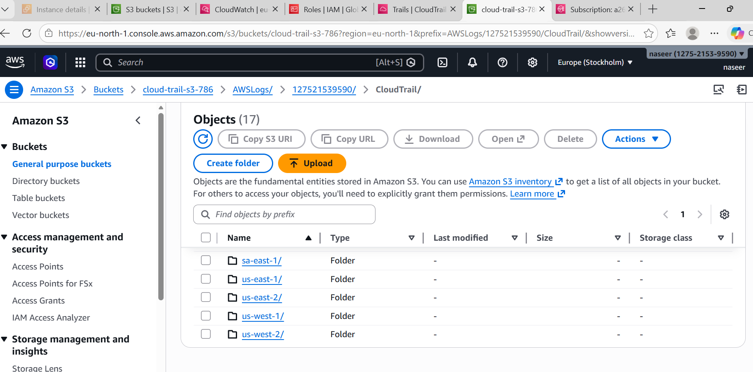
2.Enable SNS for CloudTrail to send alerts via email.
Steps:
Login in to AWS search SNS after Create topic
Type: Standard Name: CloudTrail-Alerts
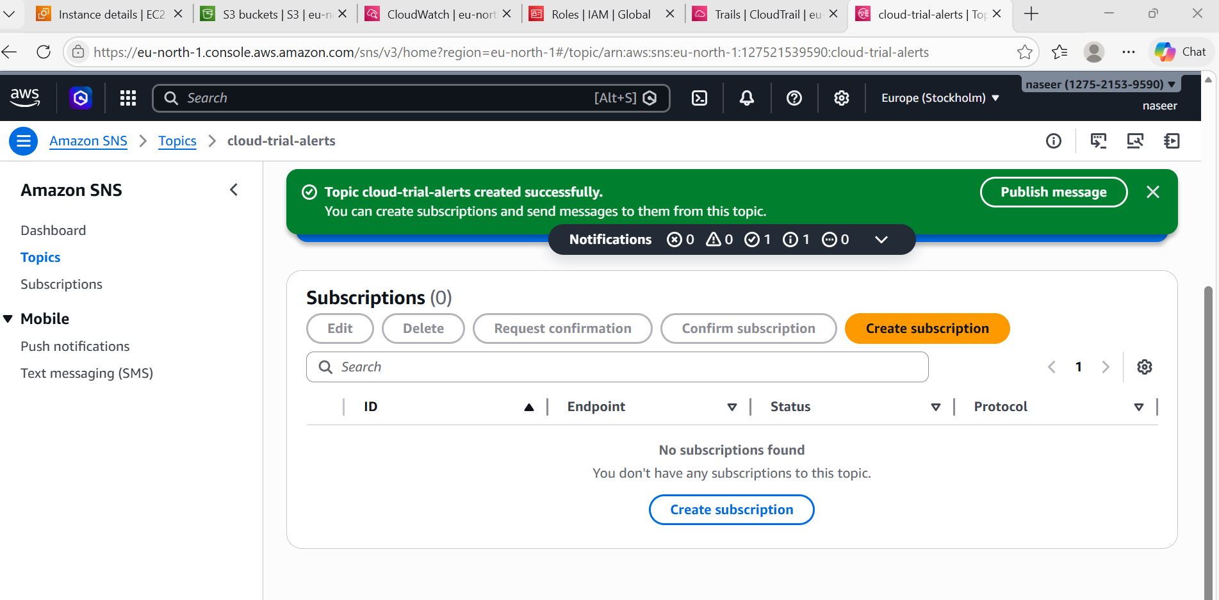
Add Email SubscriptionOpen topicClick Create subscription
Protocol: Email Enter your email
Confirm email from inbox
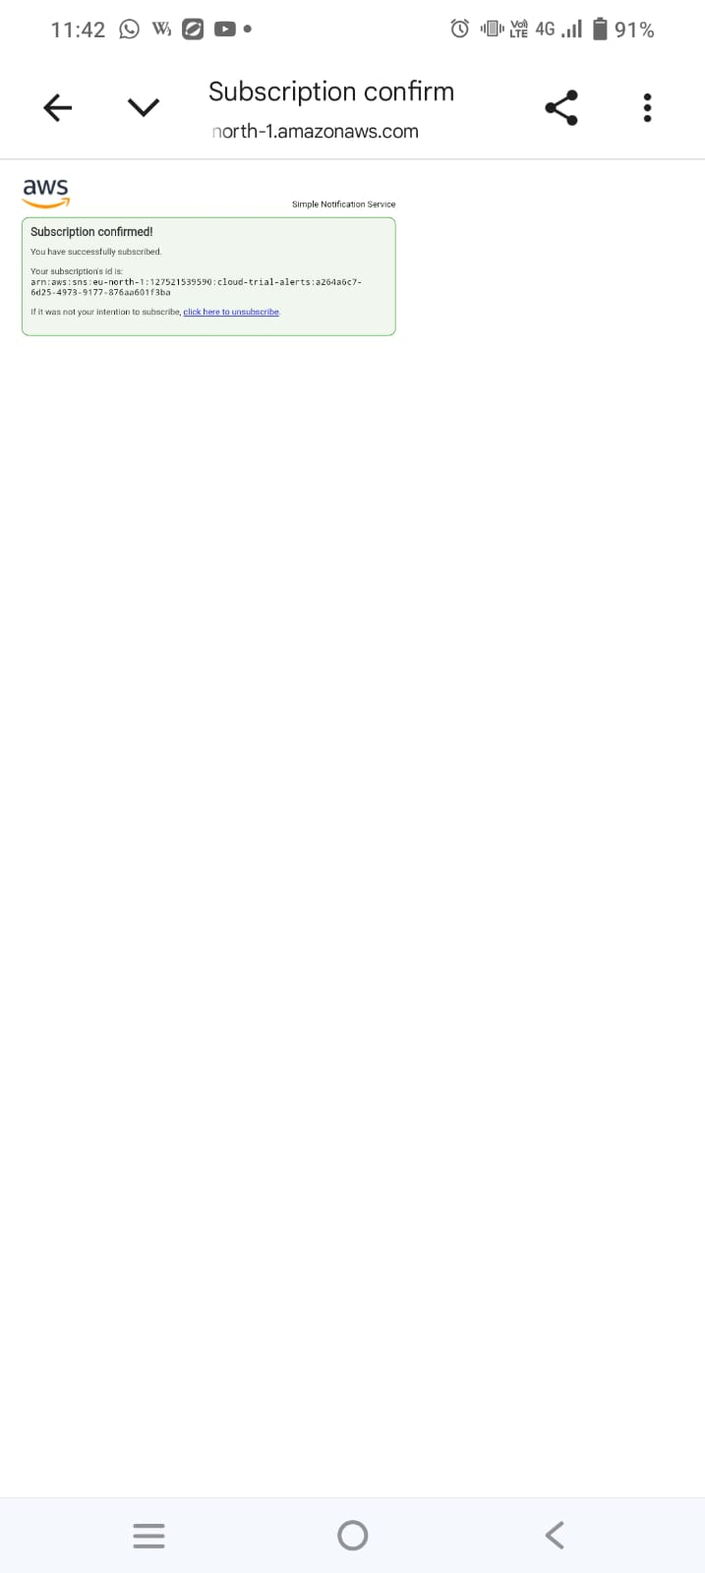

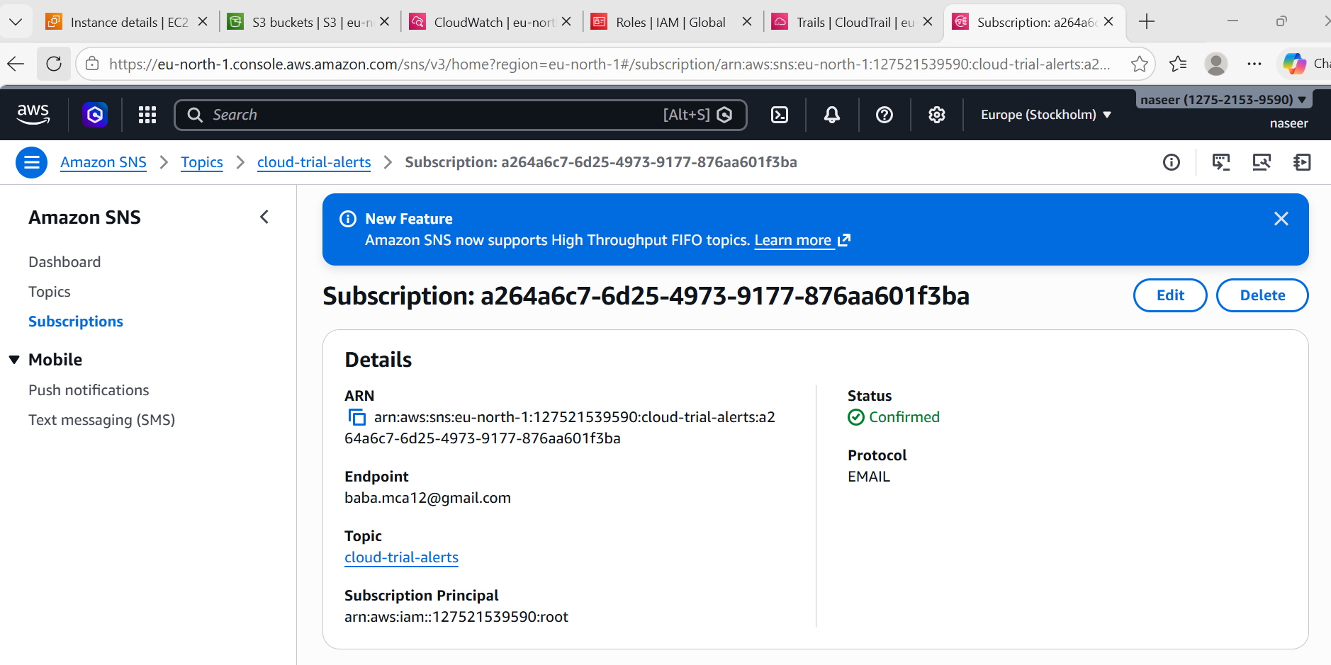

3.Configure CloudWatch monitoring and record the CPU utilization and other metrics of EC2.
Steps:
Go to EC2Launch instance
- Choose: Amazon Linux 2
- Enable:
  - Detailed Monitoring ✔
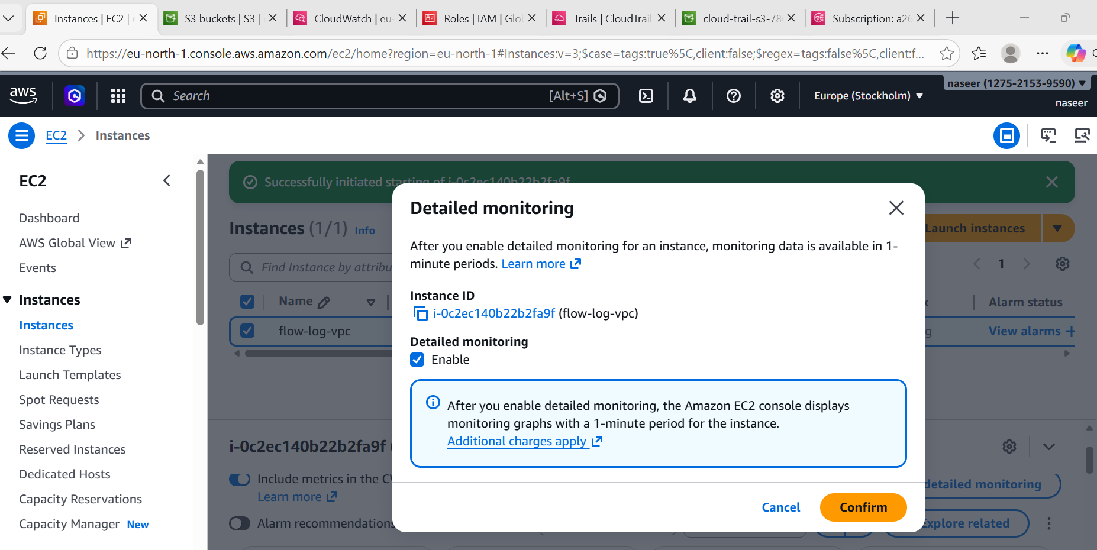
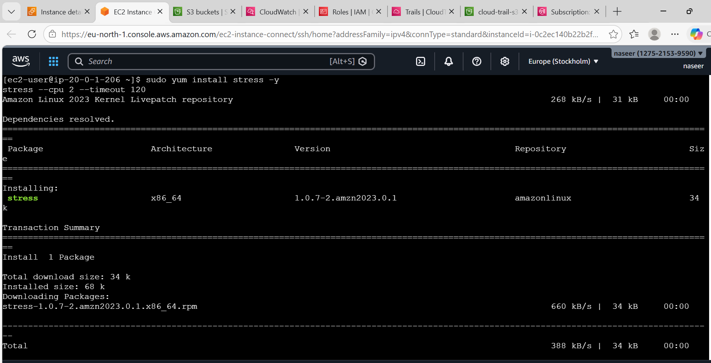
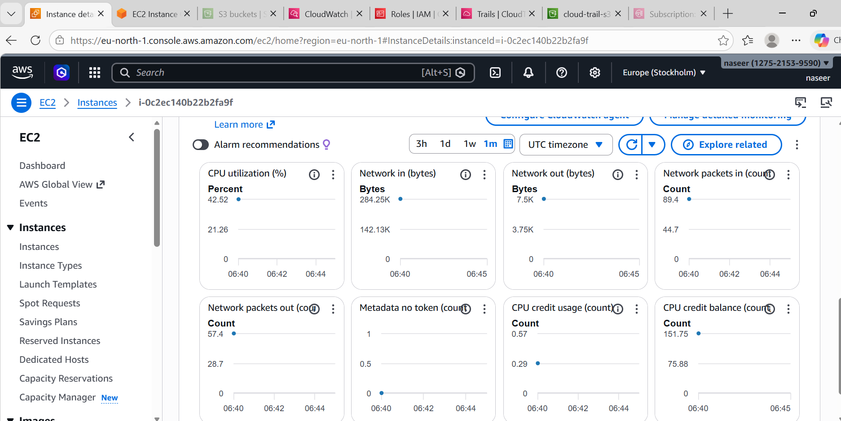
4.Create one alarm to send an alert to email if the CPU utilization is more than 70 percent.
Go to CloudWatch → AlarmsCreate alarmSelect metricEC2 → Per-Instance Metrics
Choose: CPUUtilization
Condition:
  - Threshold type: Static
  - Greater than: 70
Period: 5 minutes
Select SNS topic: CloudTrail-Alerts
Name:
EC2-High-CPU-Alarm
Email will trigger if CPU > 70%
Method 1 — Using stress
Step 1 — Connect to EC2
From your local machine:
ssh -i your-key.pem ec2-user@YOUR_PUBLIC_IP
Replace:
- your-key.pem → your key file
- YOUR_PUBLIC_IP → EC2 public IP
Step 2 — Install stress Tool
For Amazon Linux:
sudo yum update -y
sudo yum install stress -y
For Ubuntu:
sudo apt update
sudo apt install stress -y
Step 3 — Increase CPU Load (Trigger Alarm)
For t2.micro / t3.micro:
stress --cpu 1 --timeout 300
For t2.medium / t3.medium:
stress --cpu 4 --timeout 300
For High CPU Load (Force 100%)
stress --cpu 8 --timeout 600
Alternative Method (No Installation Needed)
If stress not available, use this:
yes > /dev/null &
yes > /dev/null &
yes > /dev/null &
yes > /dev/null &
This will increase CPU immediately.
To Stop CPU Load
If using stress → it stops automatically after timeout.
If using yes command → stop using: pkill yes
📊After Running Command
- Go to CloudWatch → Alarms
- Wait 2–5 minutes
- CPU should go above 70%
- Alarm state → 🔴 IN ALARM
- SNS Email should be received
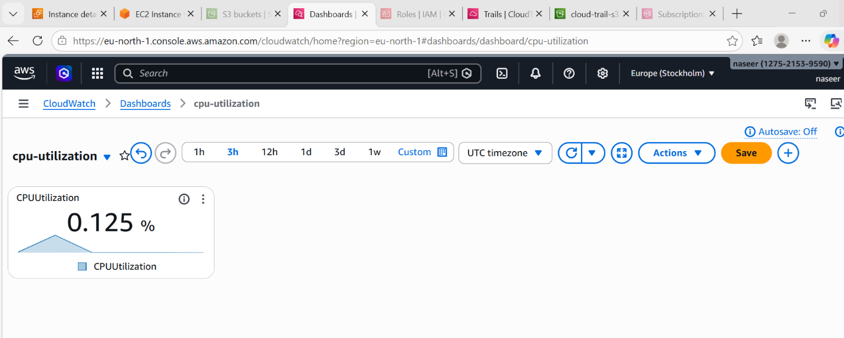
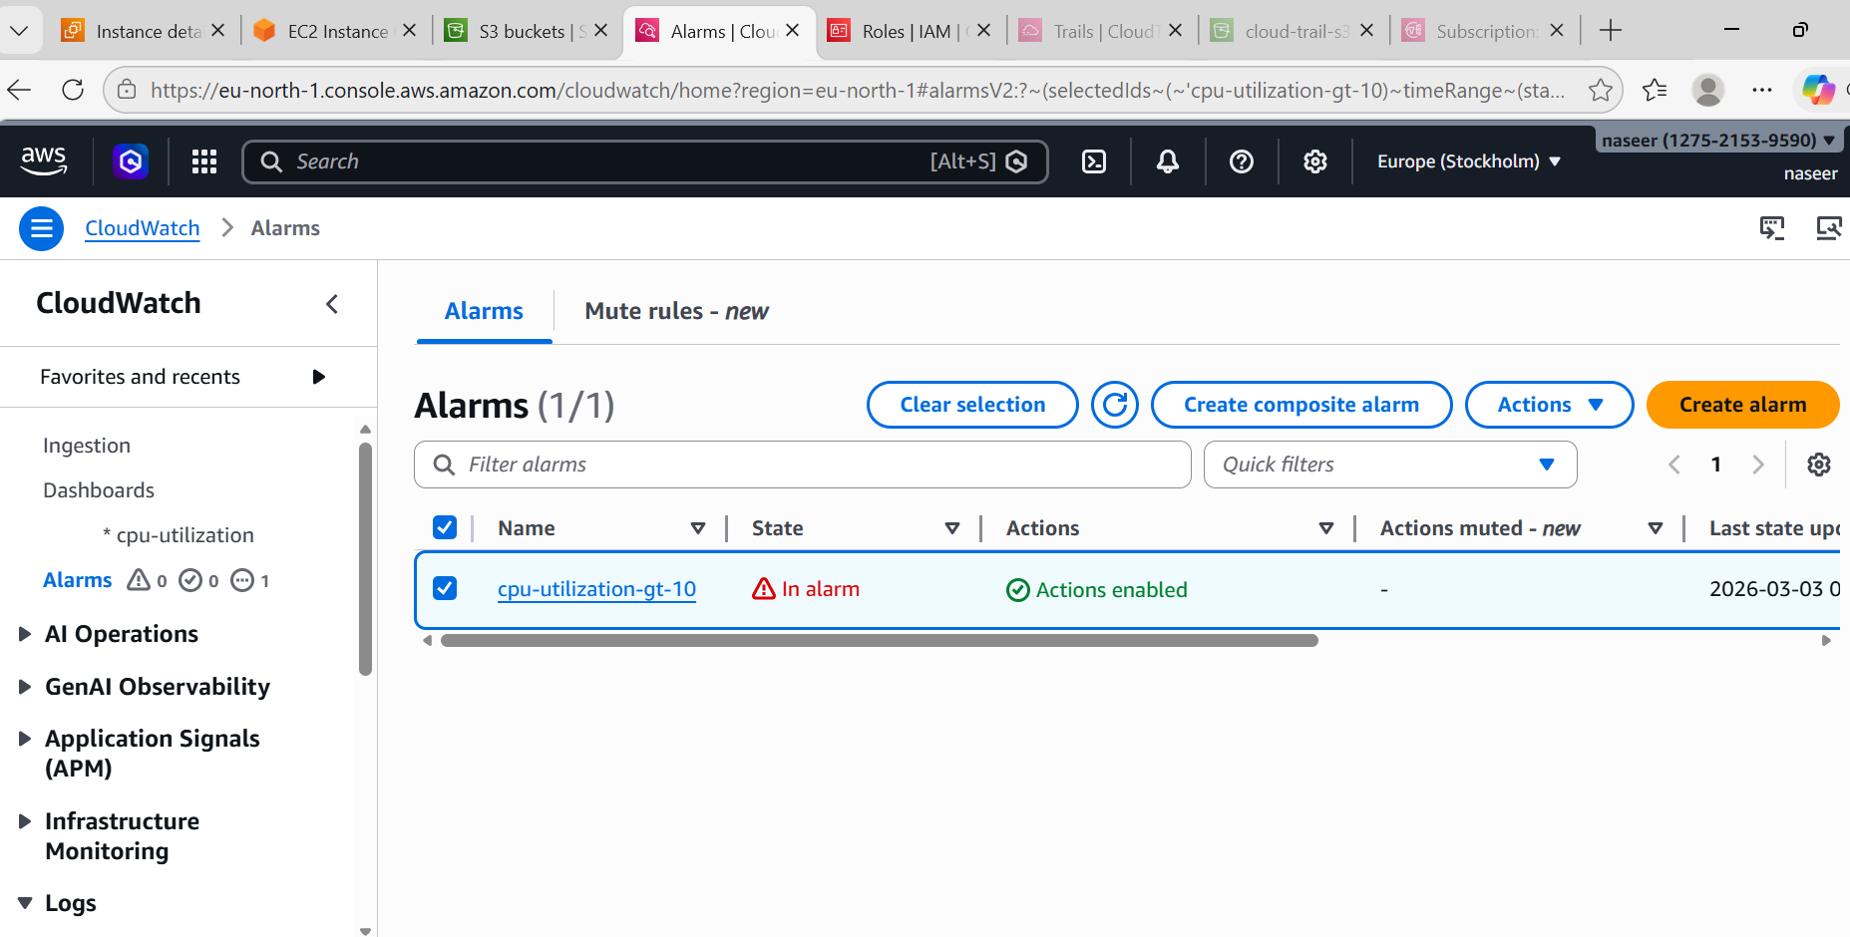
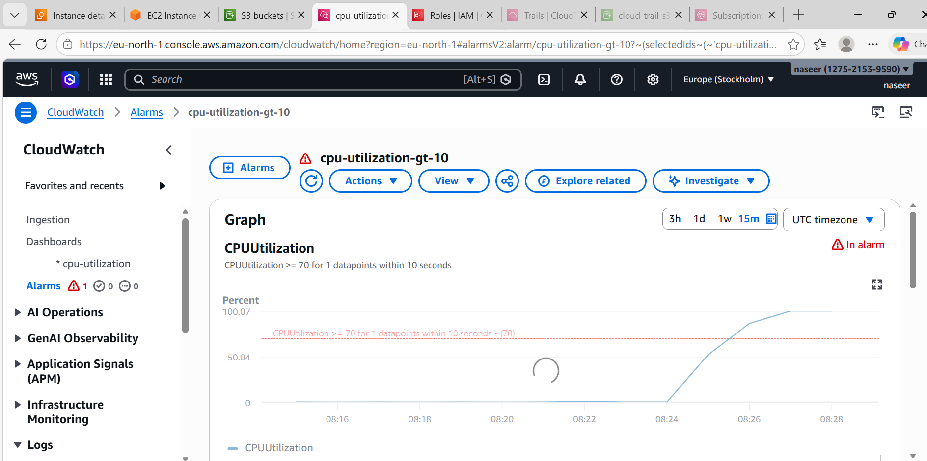
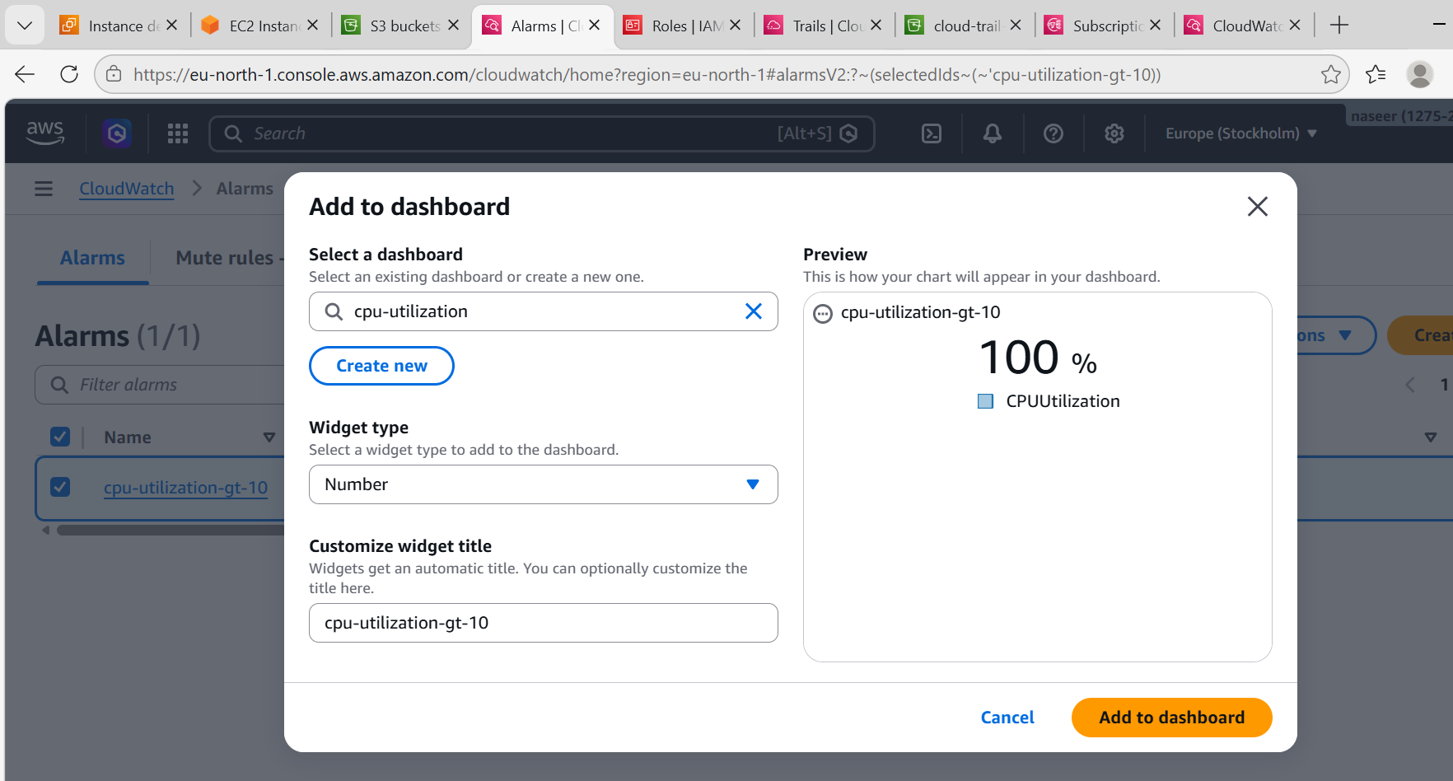
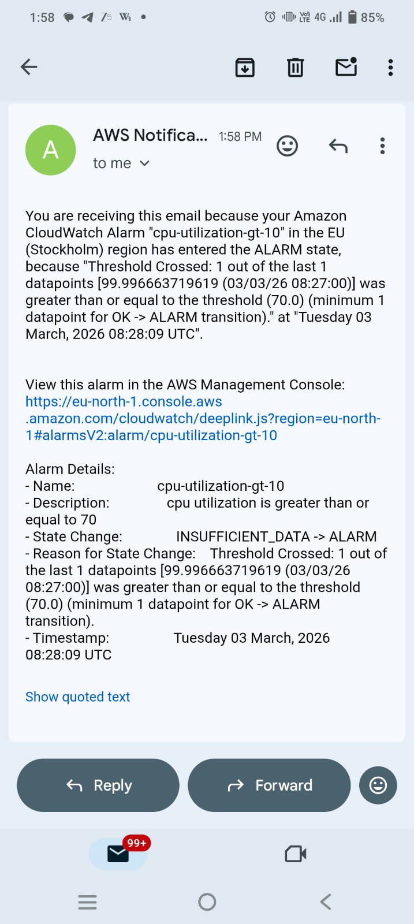
5.Create a Dashboard and monitor the Tomcat service whether it is running or not and send the alert.
Default EC2 does NOT send service status.
We must install CloudWatch Agent.

STEP 1:
ssh -i your-key.pem ec2-user@YOUR_PUBLIC_IP
Install Java:
sudo yum install java-1.8.0-openjdk -y
Install Tomcat:
sudo yum install tomcat -y
Start Tomcat:
sudo systemctl start tomcat
sudo systemctl enable tomcat
Check status:
sudo systemctl status tomcat
It must show:
active (running)
🔹 STEP 2 — Install CloudWatch Agent
sudo yum install amazon-cloudwatch-agent -y
🔹 STEP 3 — Attach IAM Role to EC2
Very Important
Go to:
EC2 → Instance → Actions → Security → Modify IAM Role
Attach role with policy:
CloudWatchAgentServerPolicy
If not available → create role:
IAM → Roles → Create role
Use case: EC2
Attach policy: CloudWatchAgentServerPolicy
Attach to EC2.
🔹 STEP 4 — Create CloudWatch Agent Config
Run:
sudo nano /opt/aws/amazon-cloudwatch-agent/bin/config.json
Paste:
{
"metrics": {
"metrics_collected": {
"procstat": [
{
"pattern": "tomcat",
"measurement": [
"pid_count"
]
}
]
}
}
}
Step 5: Start Agent
sudo /opt/aws/amazon-cloudwatch-agent/bin/amazon-cloudwatch-agent-ctl \
-a fetch-config -m ec2 \
-c file:/opt/aws/amazon-cloudwatch-agent/bin/config.json -s

Check status:
sudo systemctl status amazon-cloudwatch-agent

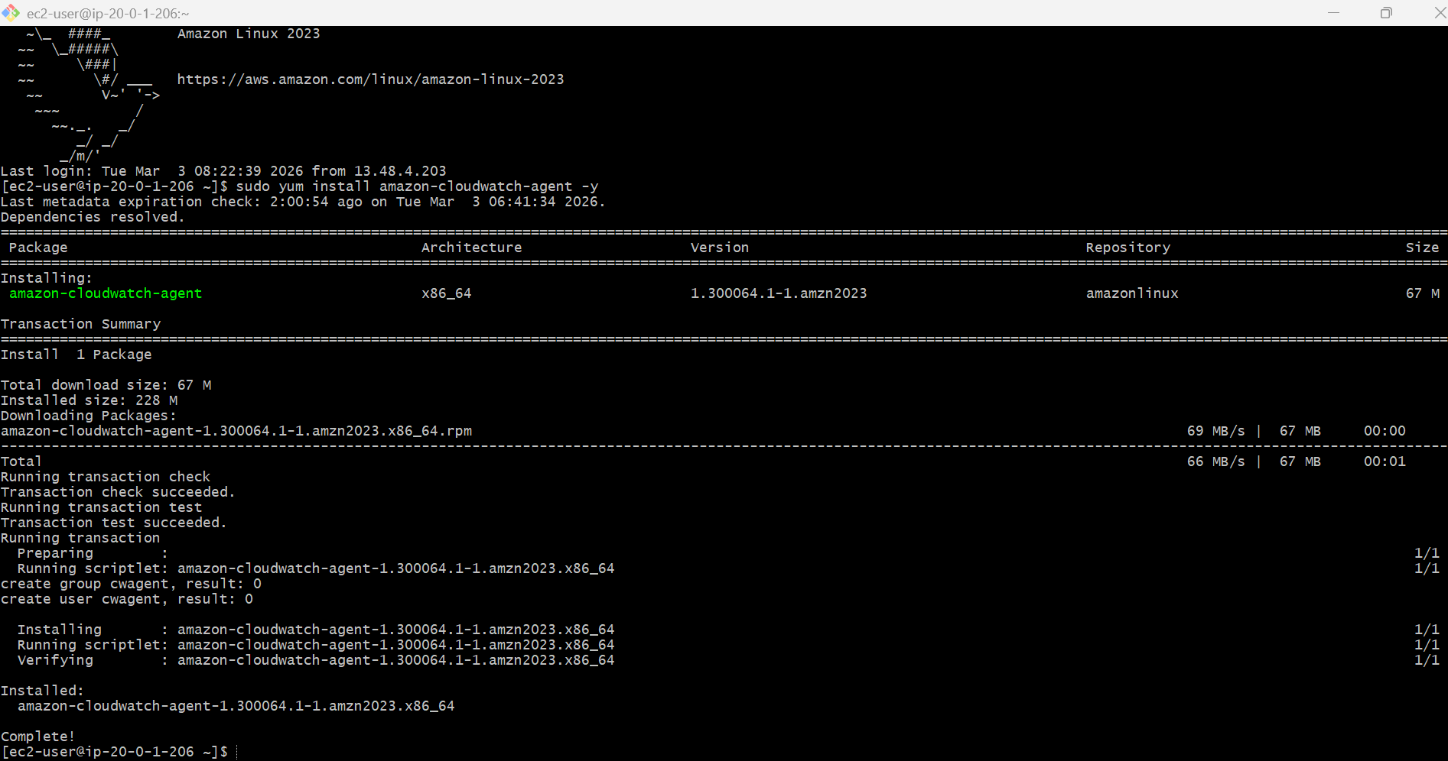
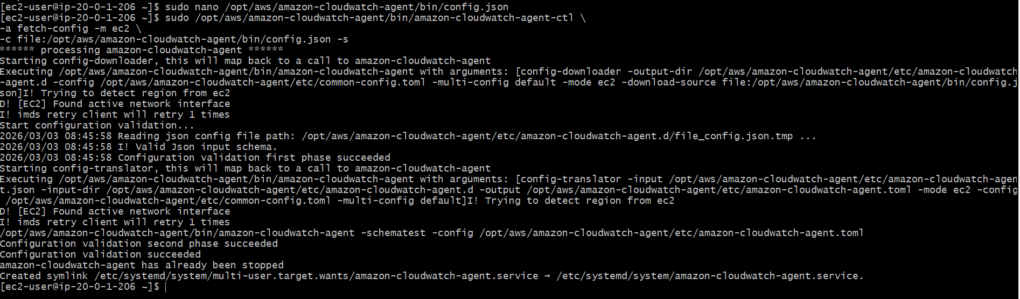
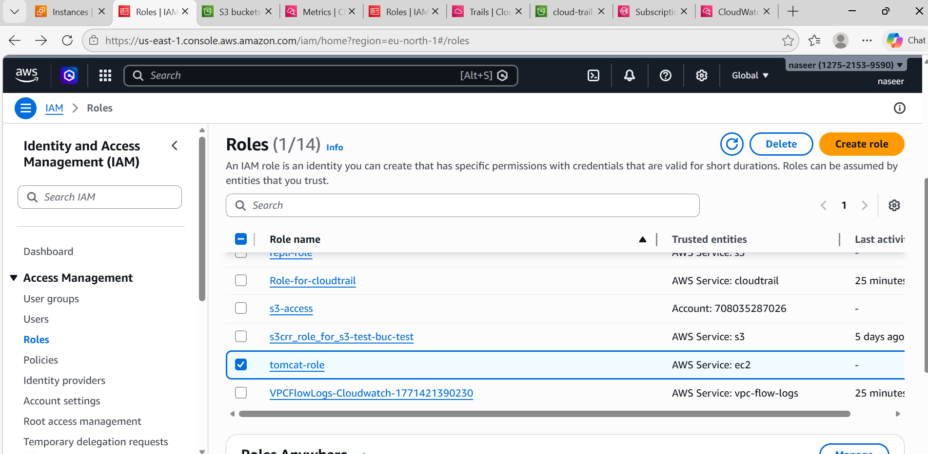
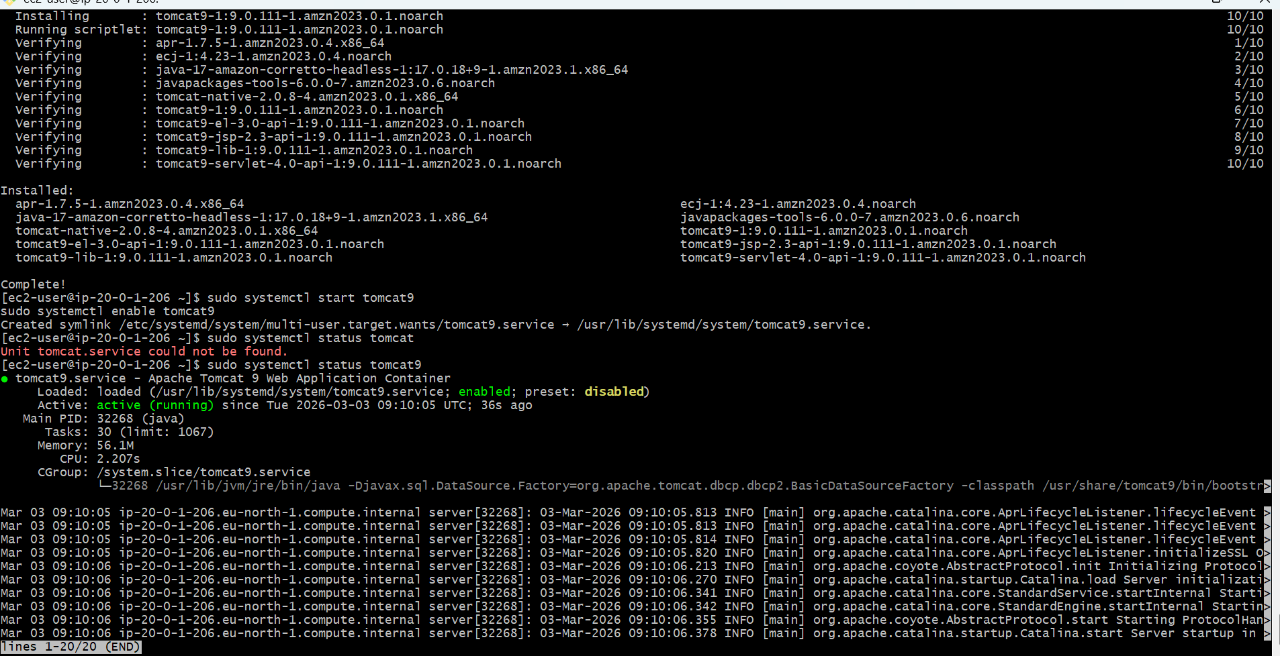
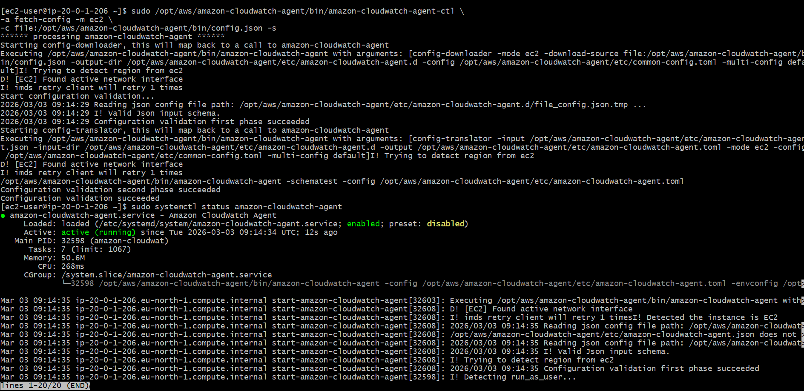
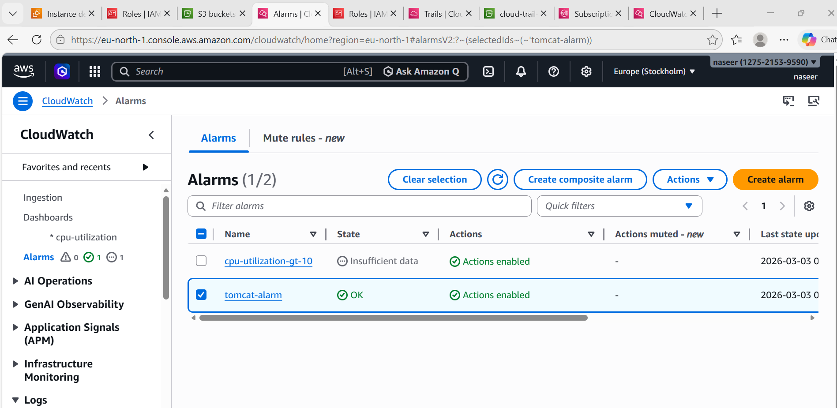
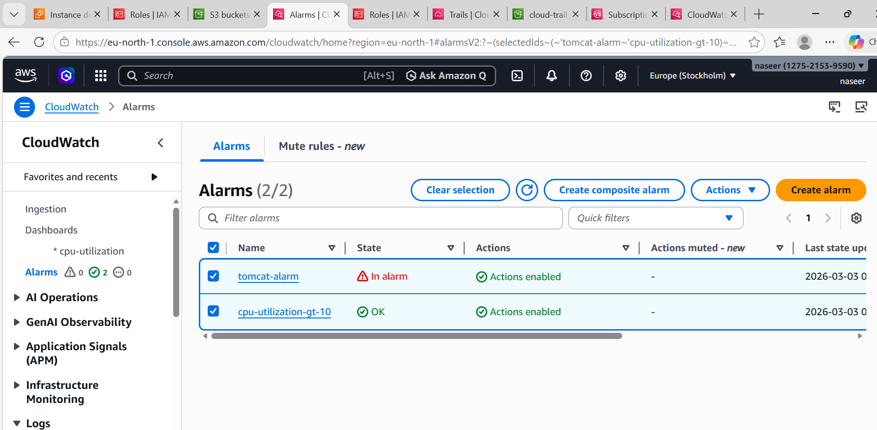
6.Create a Dashboard and monitor the Nginx service to send the alert if Nginx is not running.
STEP 1 :
ssh -i your-key.pem ec2-user@YOUR_PUBLIC_IP
Install Nginx:
sudo yum install nginx -y
sudo systemctl start nginx
sudo systemctl enable nginx
sudo systemctl status nginx
It must show:
active (running)

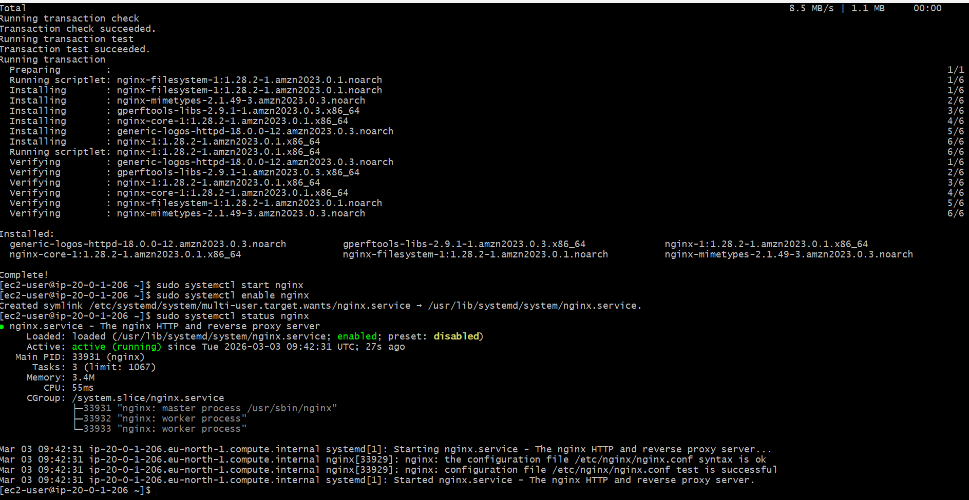
STEP 2:
Update CloudWatch Agent Config
We already configured Tomcat earlier.
Now edit config to include Nginx.
Open config:
sudo nano /opt/aws/amazon-cloudwatch-agent/bin/config.json
Replace content with this:
{
"metrics": {
"metrics_collected": {
"procstat": [
{
"pattern": "tomcat",
"measurement": ["pid_count"]
},
{
"pattern": "nginx",
"measurement": ["pid_count"]
}
]
}
}
}
Save file.
STEP 3 :
Restart CloudWatch Agent
sudo systemctl restart amazon-cloudwatch-agent
sudo systemctl status amazon-cloudwatch-agent

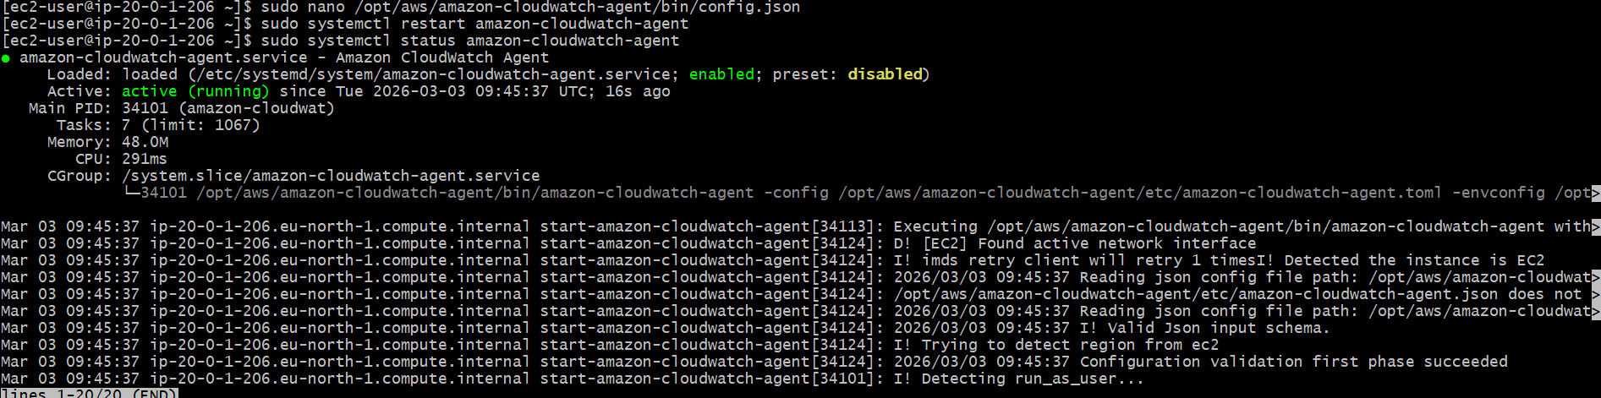
STEP 4 :
Verify Nginx Metric in CloudWatch
Go to:
CloudWatch → Metrics → All metrics → CWAgent
You should see:
procstat_lookup_pid_count
pattern: nginx
If Nginx running → value = 1
If stopped → value = 0

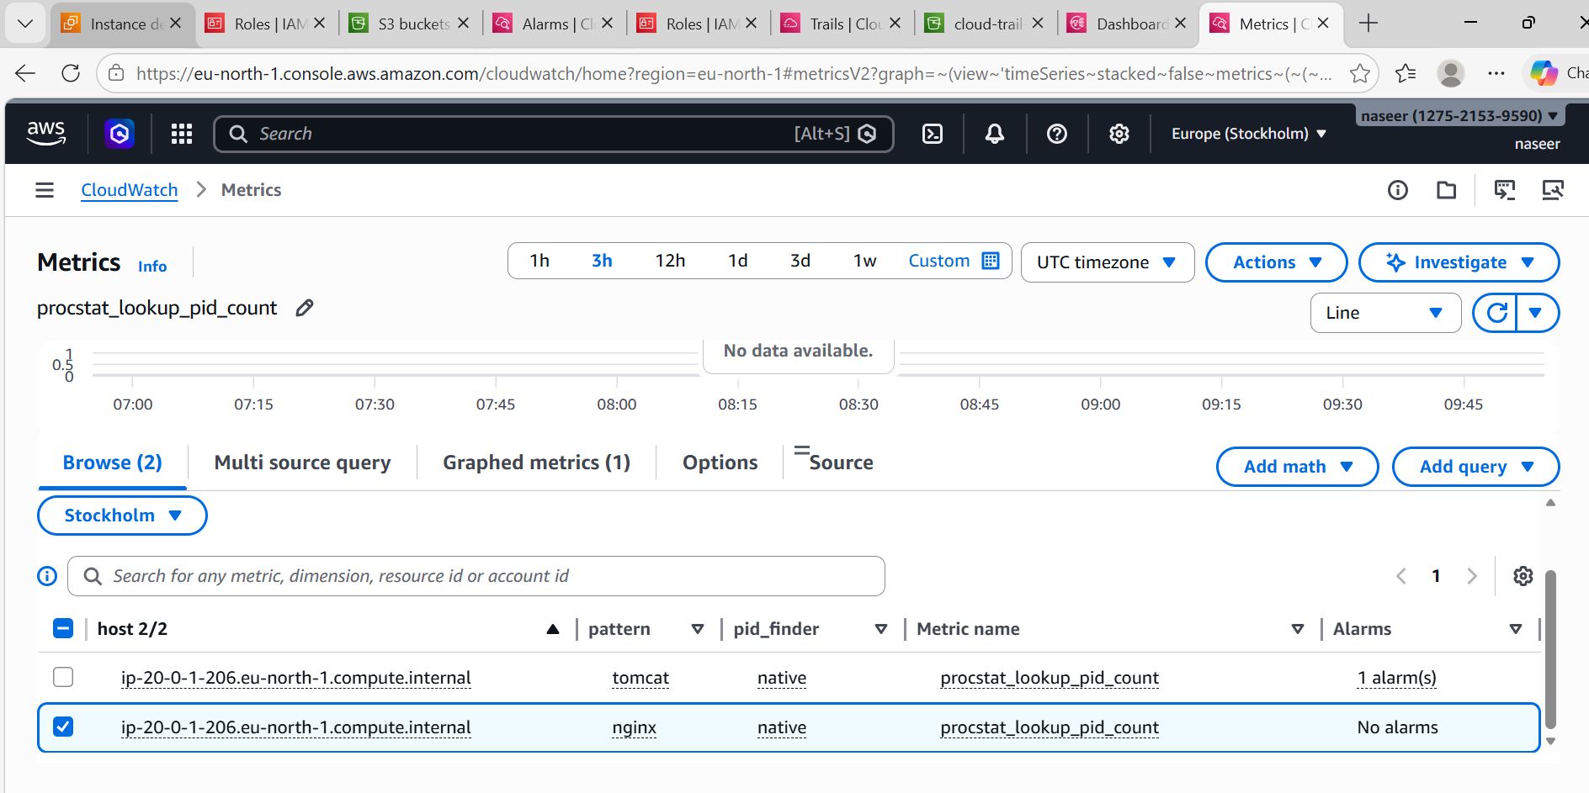
STEP 5 — Create Alarm for Nginx Down
Click the nginx metric → Click Create alarm
Configure:
- Statistic → Average
- Period → 1 minute
- Threshold type → Static
- Condition → Less than
- Value → 1
So:
pid_count < 1
Click Next
Notification:
- Choose → In alarm
- Select SNS topic → CloudTrail-Alerts
Alarm name: Nginx-Down-Alarm
Click Create alarm

